Open Email Application <https://gmail.com/>

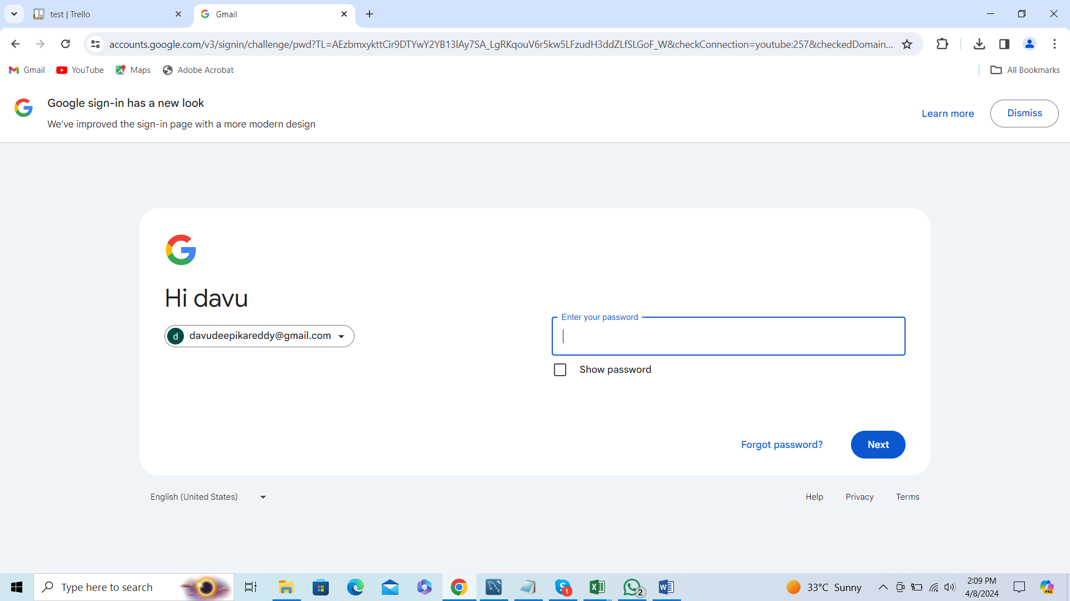

Home Page is displayed